## Getting Started with Power Automate

**Lab Time**: 60 minutes

**Lab Folder**: C:\Student\Modules\04_DesigningFlows\Lab

**Lab Overview**: In this lab, you will begin to work with Power Automate (aka Microsoft Flow). You will start by creating a simple flow which is triggered by a button. This will give you a chance to become familiar with the flow designer and the steps required to test and debug a flow. After that, you will create several more flows to build your fundamental skills with the Power Automate service.

### Exercise 1: Create and Test a Flow with Flow Button Trigger

In this exercise, you will create a new flow from blank without using a template. This will give you a chance to see how to build a flow from the ground up. In this specific case, you will create a new flow that uses the Flow button for mobile trigger which allows a user to easily kick off a flow from a mobile device.

1. Log into the Power Automate service.
   1. Using the browser, navigate to the Power Automate service at [https://flow.microsoft.com](https://flow.microsoft.com/).
   2. Click the **Sign in** link in the upper right corner and log in using your Office 365 user account.
   3. If you see the **Welcome to Power Automate** dialog, click the **Get started** button to close it..

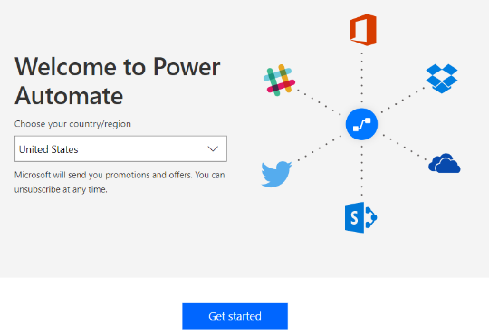

* 1. You should now be at the **Home** page of the **Power Automate** service.

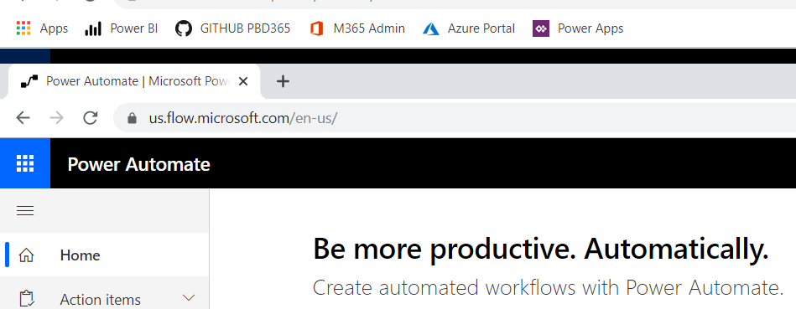

1. Create a new flow with a flow button trigger.
   1. Click the **My flows** link.
   2. Click the **+ New** button to create a new flow.

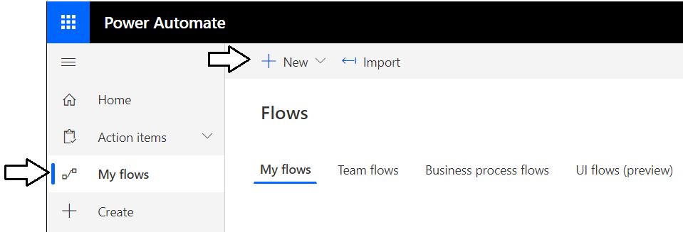

* 1. Select **Instant--from blank**.

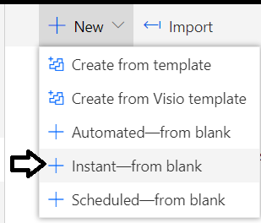

* 1. On the **Build an instant flow** dialog, enter a **Flow name** of **Idea Tracker**.
  2. For the **Choose how to trigger this flow** option, select **Manually trigger a flow**.
  3. Click the **Create** button to create the new flow.

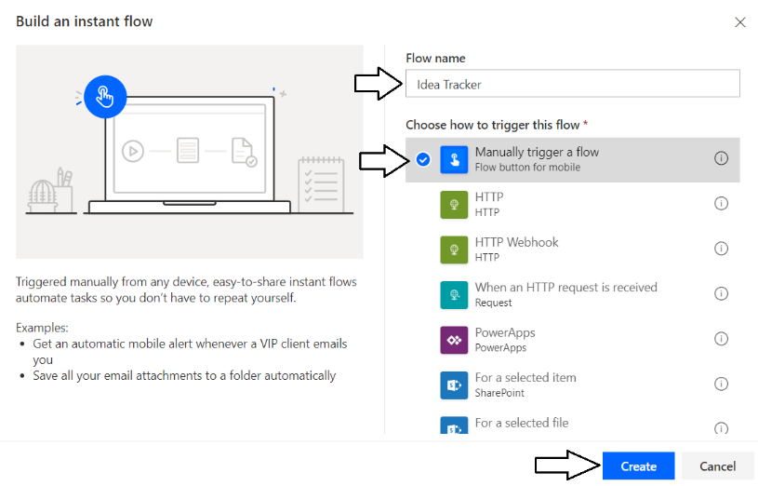

* 1. You should now see a new flow in the flow designer with the name **Idea Tracker**.

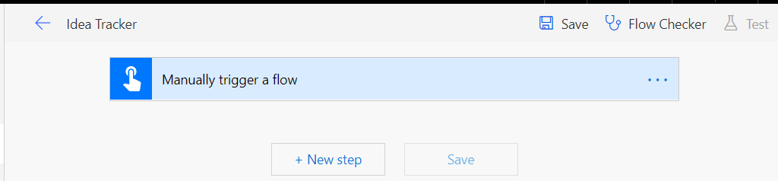

1. Add two input parameters to the flow button trigger
   1. Click on the flow button trigger on top of the text that reads **Manually trigger a flow** to display the trigger body.

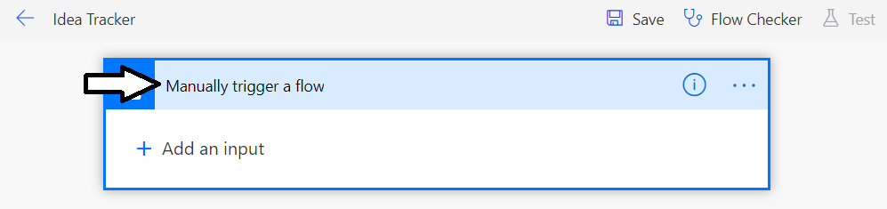

The trigger named **Manually trigger a flow** allows you to add input parameters. This makes it possible for a flow to prompt the user who is starting a flow to enter input data. In this flow, you will prompt the user for an idea and a value that indicates the idea quality.

* 1. Click the **Add an input** link.

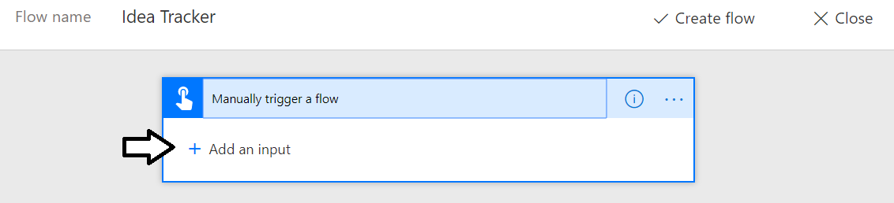

* 1. When prompted to **Choose the type of user input**, click **Text**.

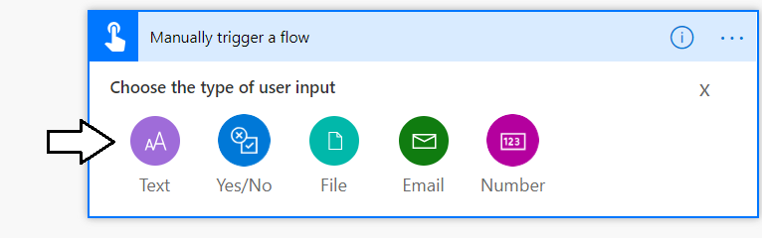

* 1. You should now see an input parameter that has been given a default name of **Input**.

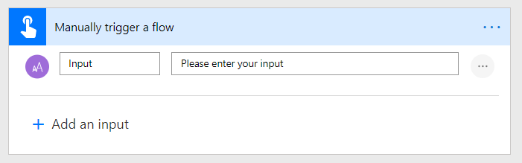

* 1. Change the parameter name to **Quality** as shown in the following screenshot.

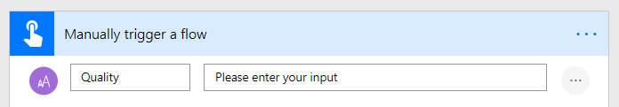

* 1. Click the ellipse (**…**) drop menu on the right-hand side of the **Quality** input parameter.

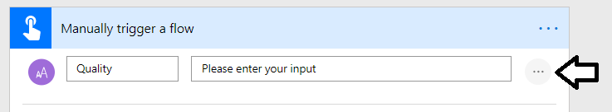

* 1. Select the option for **Add a list of options** from the dropdown menu.

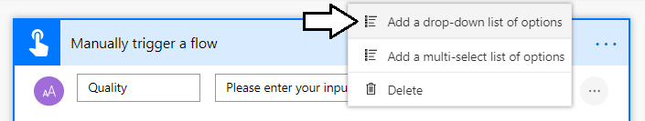

* 1. Under **List Options**, add four choices which include **Lame**, **Good**, **Great** and **Genius** as shown in the following screenshot.

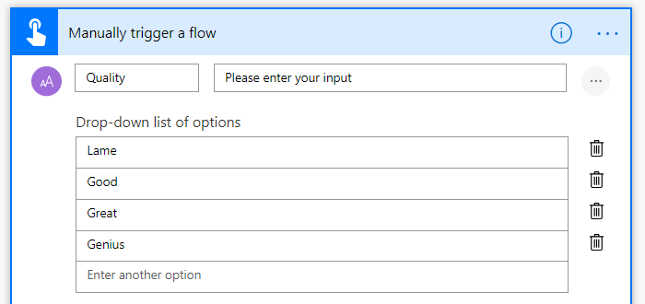

* 1. Click **Add an input** to add a second input parameter.

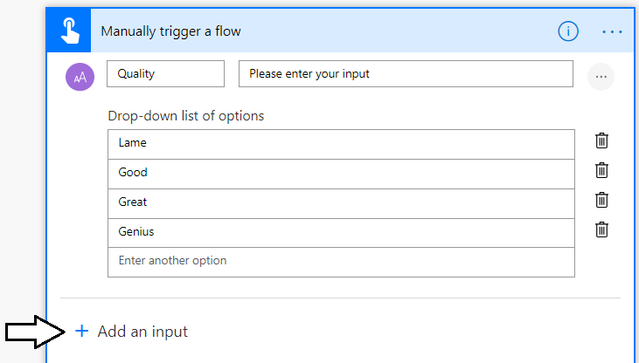

* 1. When prompted to **Choose the type of user input**, click **Text**.
  2. Change the name of the second input parameter to **Idea**.

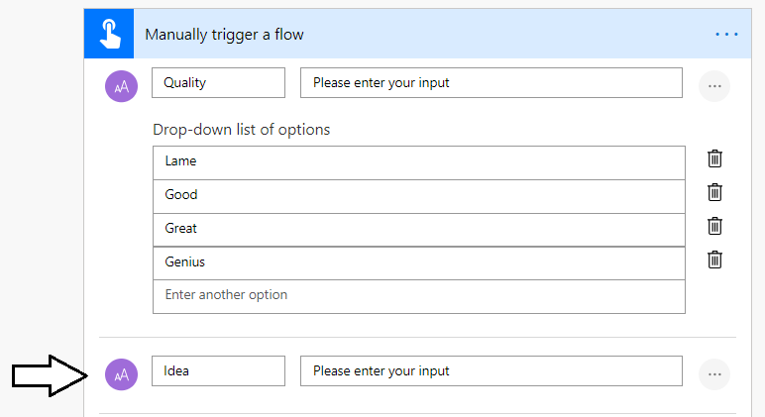

1. Add an action to send an email message every time the flow is triggered.
   1. Click **New Step** at the bottom of the Flow Designer to add a new action.
   2. Type **"send email"** into the search box to search for the **Send an email (V2)** action.
   3. Select the **Send an email (V2) - Office 365 Outlook** action.

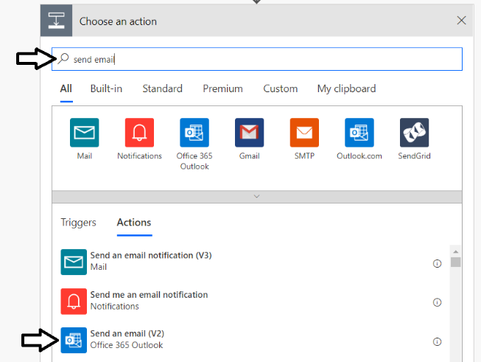

Note that in addition to the **Send an email (V2)** action, there are several other actions for sending email messages. The action named **Send an email (V2)** provides an enhanced HTML editor for authoring the email body.

* 1. In the **Send an email** action, add your Office 365 trial account email address to the **To** field.
  2. In the **Subject** field, add the **Quality** field from flow data followed by a space and the text **"Idea for Consideration"**.
  3. In the **Body** field, add the **Idea** field from flow data.
  4. When you are done, the **Send an email (V2)** action should match the following screenshot.

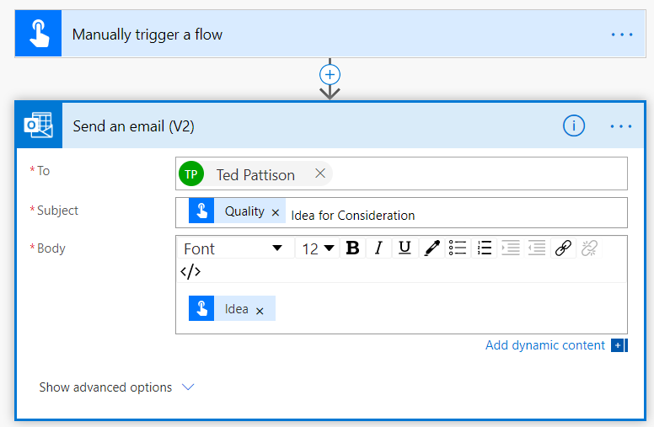

* 1. Click the **Save** button at the bottom of the Flow Designer to save your flow.

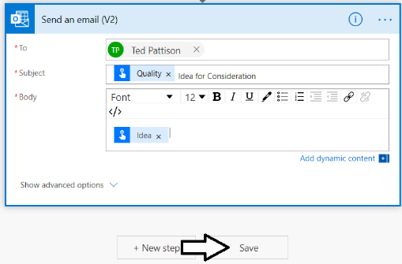

1. Test the **Idea Tracker** flow by running it from the browser.
   1. Click the **Test** button at the top right to manually trigger the flow.

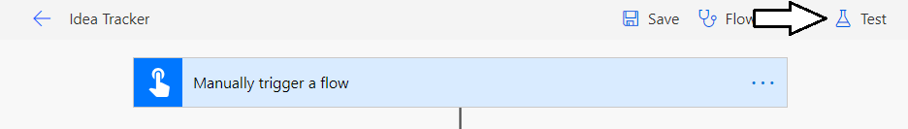

* 1. Select the option **I'll perform the trigger action** and then click the **Save & Test** button.

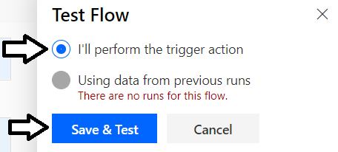

* 1. If prompted, sign in with your Office 365 user account and grant permissions to the **Office 365 Outlook** connector.
  2. Click the **Continue** button.

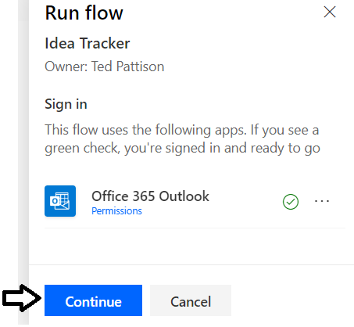

You should now be prompted with a page that allows you to enter values for the two input fields named **Quality** and **Idea**.

* 1. Enter some sample test values for the input fields named **Quantity** and **Idea** and then click **Run flow**.

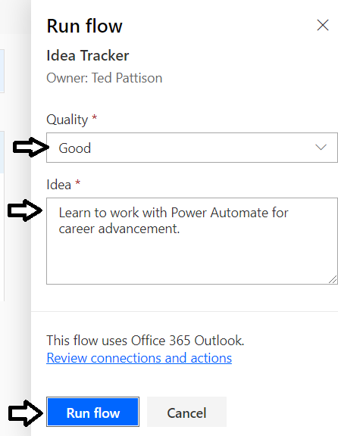

* 1. You should see a message indicating that the flow run started successfully. Click the **Done** button.

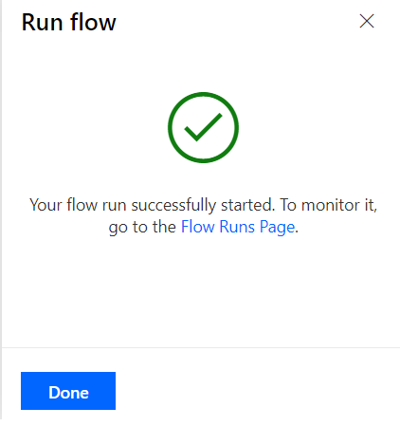

* 1. You should now see the flow run page for the flow that just ran.

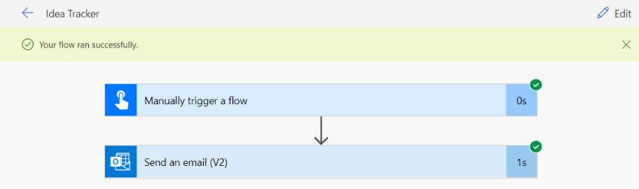

* 1. Click the back arrow button to the right of the flow title to move back to the flow summary page.

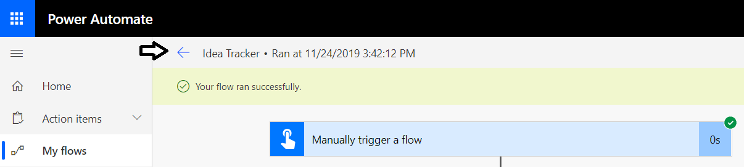

* 1. You should now be at the **Idea Tracker** summary page which displays flow details and a toolbar with commands buttons.

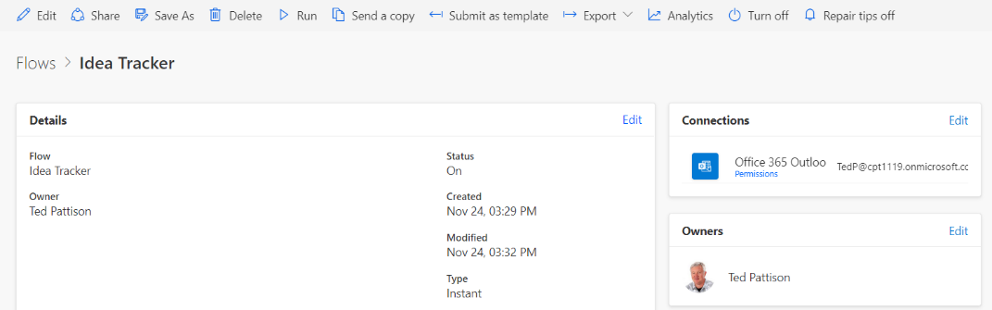

* 1. Click the **Run** button to run the flow once more.

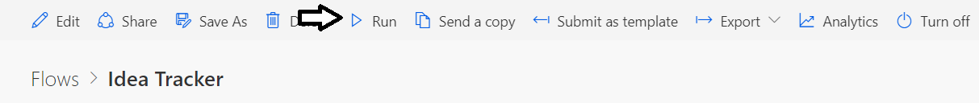

Earlier, you ran this flow from the flow editor as a test run. Now you are running flow in the standard production mode for flow runs as opposed to running it in test mode.

* 1. Provide creative values for the two **Idea Tracker** input parameters and then click the **Run flow** button.

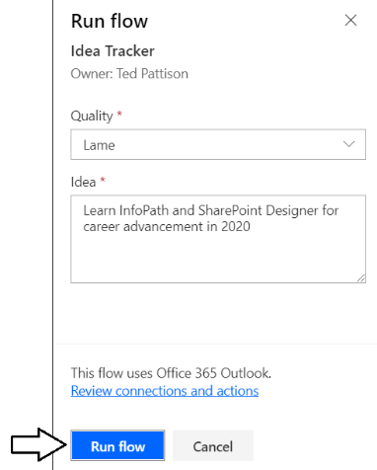

* 1. After the flow has run, inspect the **Runs** section of the **Idea Tracker** flow summary page.

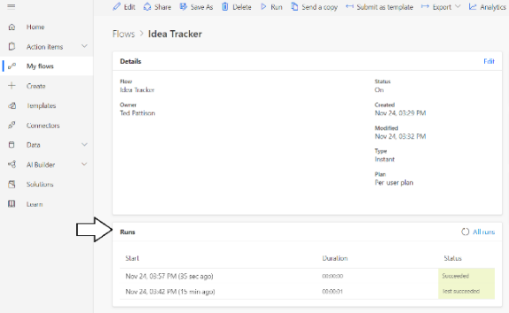

* 1. Look at the **Status** column of the **Runs** list and observe it differentiates between standard runs and test runs.

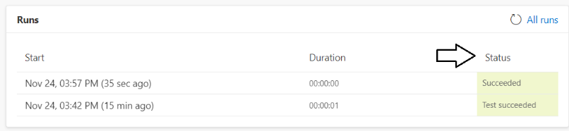

1. Check your Outlook inbox to see the message created by the **Idea Tracker** flow.
   1. Return to your inbox in Outlook.
   2. Verify that you received the message with your idea.

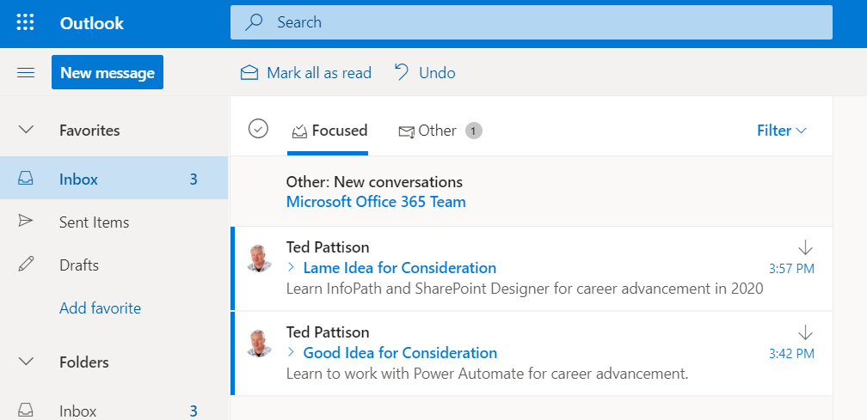

### Exercise 2: Create a Flow to Generate a Word Document from a SharePoint List Item

In this exercise, you will create a new flow that is triggered by selecting a customer item from the SharePoint **Customers** list. You will build the flow to generate a new Word document and populate its content from data in the SharePoint list item that triggered the flow.

1. Create a SharePoint document library to store letters that are generated by the flow you will create in this exercise.
   1. Navigate to your SharePoint site.
   2. Click the **Add an app** menu command from the **Site Actions** menu.

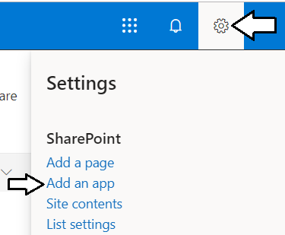

* 1. Select a list type of **Document Library**.

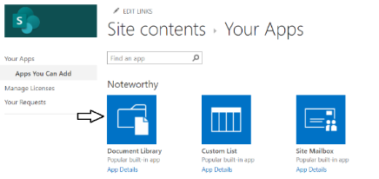

* 1. Enter a **Name** of **Letters** for the document library and click **Create**.

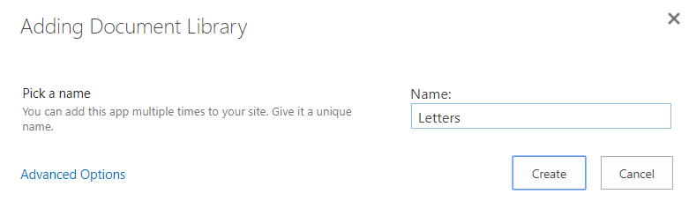

1. Create a folder inside the **Letters** document library to store a letter template.
   1. Once the **Letters** document library has been created, navigate to its default view.

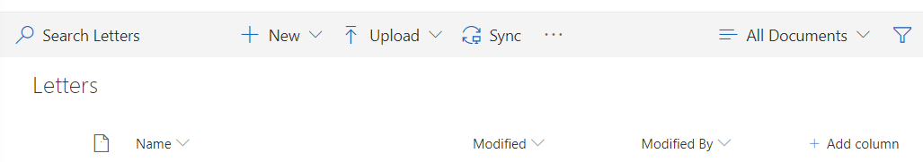

* 1. Click the **New > Folder** command to create new folder.

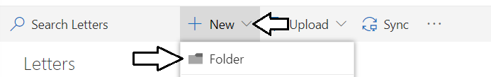

* 1. Give the new folder a name of **Templates** and click **Create** to create the new document library.

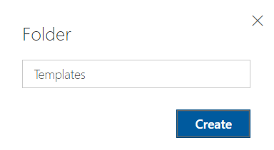

* 1. Once the **Templates** folder has been created, click on the **Templates** link to navigate inside the folder.

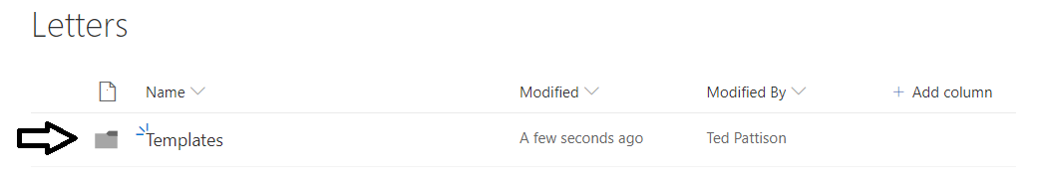

* 1. Once you have navigated inside the **Templates** folder, click the **Upload** button to upload a Word template file into that folder.

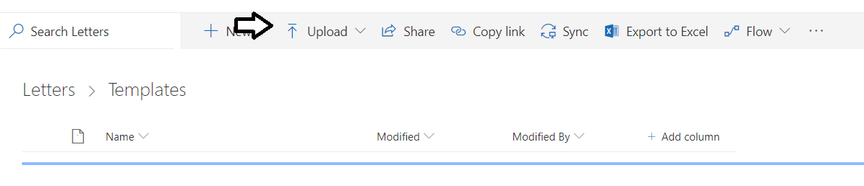

* 1. Upload the file named **CustomerLetterTemplate.docx** which is located in the **Student** folder at the following path.

C:\Student\Modules\04_DesigningFlows\Lab\CustomerLetterTemplate.docx

* 1. Verify that **CustomerLetterTemplate.docx** has been uploaded to the **Templates** folder.

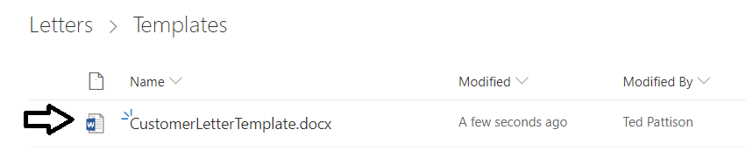

1. Create a new flow on the SharePoint **Customers** list using the **For a selected item** trigger.
   1. Navigate to the **Customers** list in your SharePoint site.
   2. Drop down the **Flow** menu in the ribbon and select the **Create a flow** command.

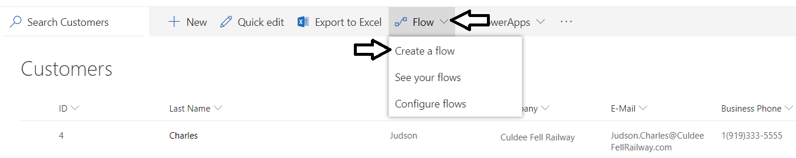

* 1. When you see the **Create a flow** pane on the right, click the **Show more** link at the bottom.

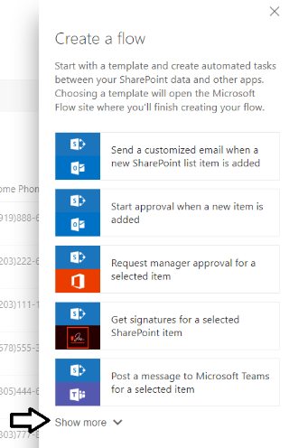

* 1. Scroll to the bottom of the templates list and select the template named **Complete a custom action for the selected item**.

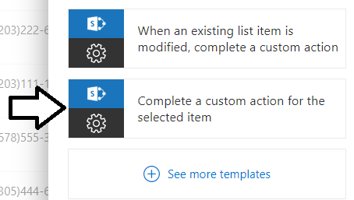

* 1. When prompted to grant permissions for a new SharePoint connection, click **Continue**.

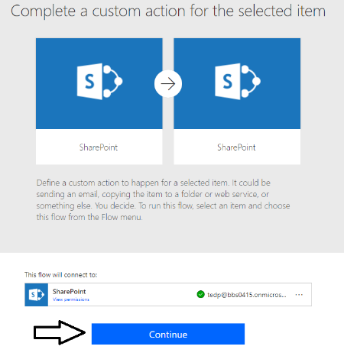

* 1. You should now see a new flow with a **For a selected item** trigger at the top and a **Get item** action below.

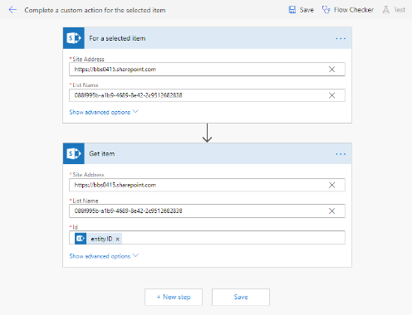

* 1. At the top left, locate the flow **Name** which has a default value of **Complete a custom action for the selected item**.



* 1. Update the **Name** of the flow to **Generate Customer Letter**.



1. Add a new step to generate a new Microsoft Word document using customer data from the selected customer item.
   1. Underneath the **Get item** action, click **New step** button to add a new step to the bottom of the flow.
   2. Type **Word** into the action search box.
   3. Locate and select the action named **Populate a Microsoft Word template**.

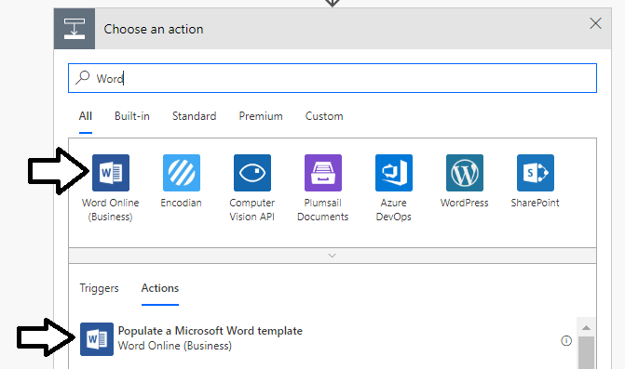

* 1. The **Populate a Microsoft Word template** action should appear in the flow designer.

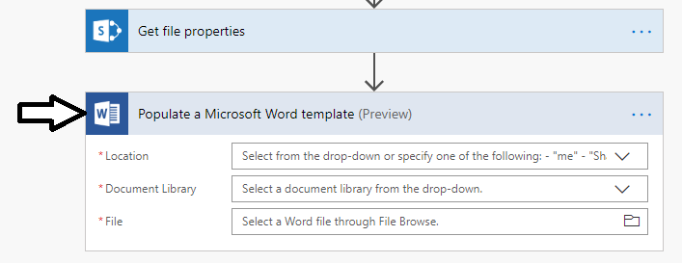

* 1. Configure the **Location** parameter to reference your SharePoint site.
  2. Configure the **Document Library** parameter to reference the **Letters** document library.

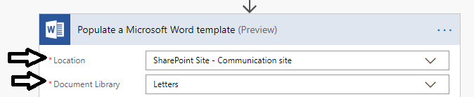

* 1. Configure the **File** parameter to reference the template file named **CustomerLetterTemplate.docx** in the **Templates** folder.

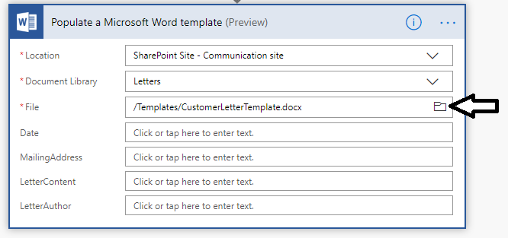

Once you configure the **File** property to reference the template file named **CustomerLetterTemplate.docx**, the flow designer discovers the input fields in the Word template named **Date**, **MailingAddress**, **LetterContent** and **LetterAuthor** and provides an opportunity for you to initialize these input field values using content generated from the selected customer item.

1. Initialize the **Date** input field for the Word document template.
   1. Place your cursor in the textbox for the **Date** parameter and then click the **Expressions** tab on the right.

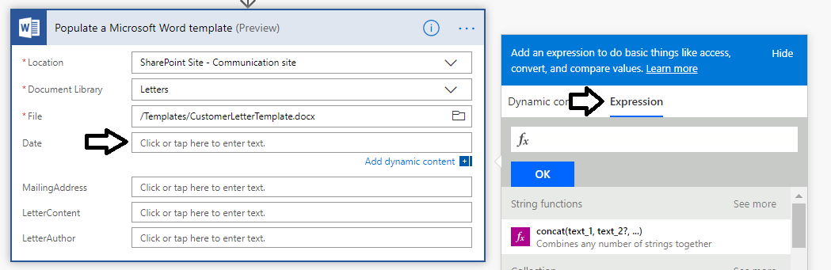

* 1. Copy the following WDL expression into the clipboard and then paste it into the **Expressions** textbox.

convertTimeZone(utcnow(),'UTC','Eastern Standard Time','MMM d, yyyy')

* 1. Once you have pasted the expression into the **Expression** textbox, click the **OK** button to save your changes.

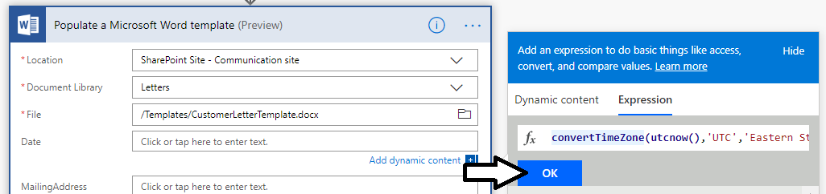

* 1. You should be able to verify that the expression with the **convertTimeZone** function has been entered correctly.

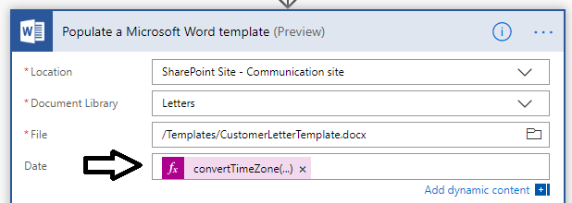

1. Initialize the **MailingAddress** input field for the Word document template.
   1. Place your cursor inside the textbox for the **MailingAddress** parameter.
   2. Click the **First Name** output parameter from the **For a selected item** trigger.

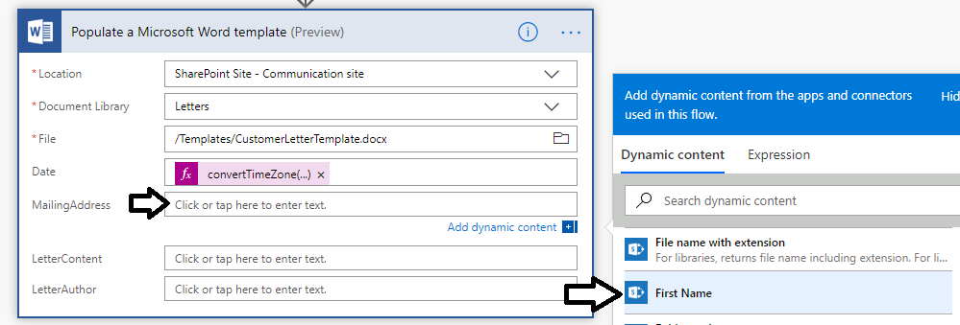

* 1. Place the cursor after **First Name** and add a space.

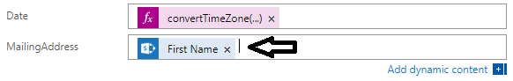

* 1. After the space, add the **Last Name** parameter from the **For a selected item** trigger.

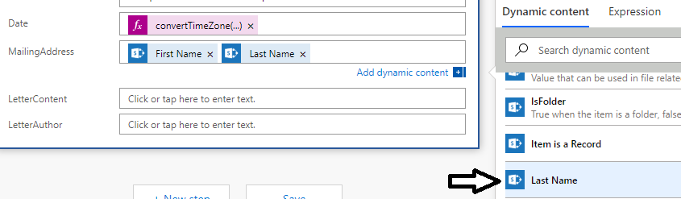

* 1. Next, add a line break
  2. Add **Address**.
  3. Add another line break.
  4. Add **City** followed by a comma (**,**) and then a space.
  5. Add **State/Province** followed by two spaces and then **ZIP/Postal Code**.

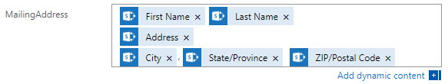

1. Add a new **Compose** step to build the content for the **LetterContent** input field.
   1. Click the **+** button in between the **Get item** action and the **Populate a Microsoft Word template**.

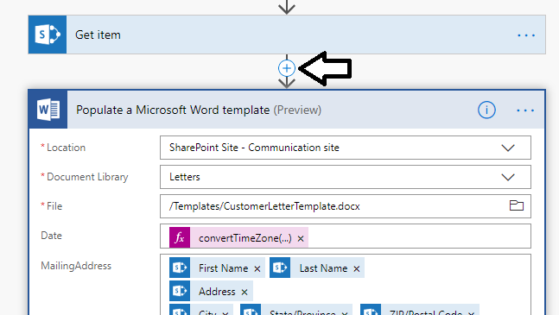

* 1. Select the **Add an action** command.

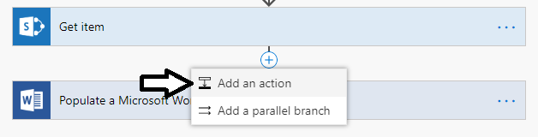

* 1. Type **Compose** into the action search textbox.
  2. Locate and select the **Compose** action.

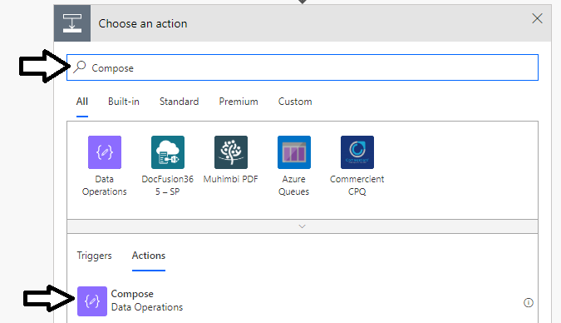

* 1. You can see that the **Compose** action has one input parameter named **Inputs**.
  2. Click the ellipse context menu on the right of the **Compose** action and select the **Rename** command.

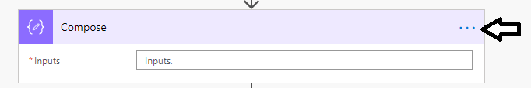

* 1. Rename the action to **Letter Body**.

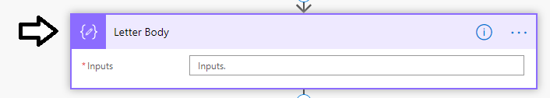

* 1. Place your cursor inside the **Inputs** textbox and type "**Dear**" followed by a space.
  2. Next, add the **First Name** output parameter from the **For a selected** item trigger.

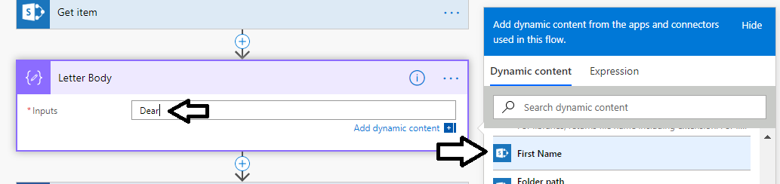

* 1. Enter a comma (**,**) followed by a line break.

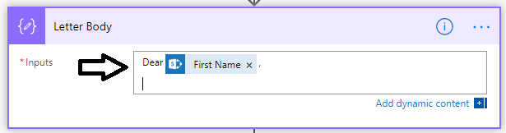

* 1. Enter content for the letter body by copying and pasting the following text.

Lorem ipsum dolor sit amet, id omnis viderer blandit pri, duo in vide nominati consequuntur, duo ne admodum tractatos. An velit iudico phaedrum vim, no saepe altera duo, sea duis assum id. Cu mel facilisi rationibus, in eros albucius per, cum id movet graecis. Ex vel tollit civibus repudiare, quidam audire vituperatoribus pri an. An eros utinam has.

Dicat veniam reprehendunt usu eu, id pri stet qualisque. Vis tale quaeque incorrupte ea, mea quaestio imperdiet ei, per eu perfecto lobortis argumentum. Ad his viris appetere gloriatur. Ei eos elit appareat complectitur. Quo novum aperiri accusamus ei, duis nostrud cum no, at vel dolorum recusabo patrioque.

Vim no eius verterem urbanitas, error veniam vim an. Ut possit aperiam sed, veniam oporteat sapientem has eu, pro civibus evertitur ne. Saepe impetus id vis, vel iudico tantas epicurei te. Pri praesent instructior eu, vix quod lorem commune ei, mea facilisi tacimates antiopam eu.

Erant animal te nam, ius praesent imperdiet abhorreant an. Mea unum dicam gloriatur eu, quem molestie accusamus vel te. Dicam nonumes at mei, omnis veritus adipisci ne eos. Everti mnesarchum in eam, no ius aeque vulputate. An debet referrentur vim, duo ne amet melius.

Duo magna mediocrem ocurreret et. Mollis voluptatum ei eam. Placerat scripserit an has, vitae tempor vim no. Oblique admodum iudicabit est in. Ut suavitate disputationi eum, et modo error commune quo.

Augue fabulas id vel. Nec dico legimus an, diceret qualisque his eu. Molestiae laboramus ex eam, in sumo essent dignissim his, eu delicata liberavisse mea. Vis ut iudico graeco iriure. Per veniam eleifend ad, eu sit novum tempor menandri.

* 1. The **Inputs** parameter of the **Letter Body** action should now contain content for the letter body.

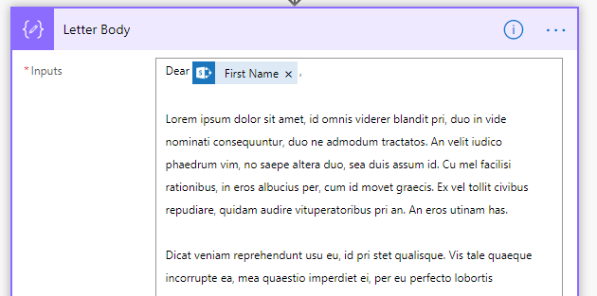

* 1. Place your cursor inside the **LetterContent** parameter of the **Populate a Microsoft Word template** action.
  2. Configure the **LetterContent** parameter by assigning the **Output** property of the **Compose** action named **Letter Body**.

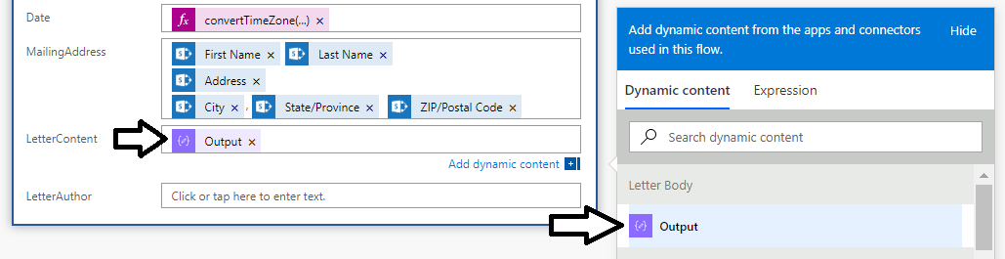

1. Initialize the **LetterAuthor** input field for the Word document template.
   1. In the **Populate a Microsoft Word template** action, place your cursor inside the textbox for the **LetterAuthor** parameter.
   2. Configure the **LetterAuthor** parameter by assigning the **User name** parameter of the **For a selected item** trigger.

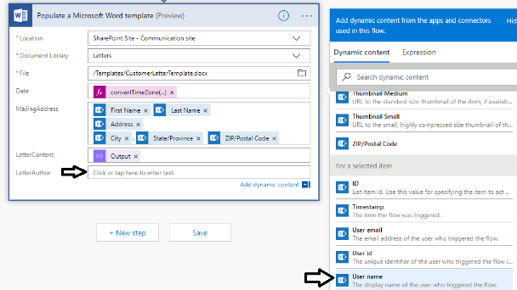

* 1. Verify that the **User name** parameter has been assigned to the **LetterAuthor** input field



1. Add a new SharePoint **Create File** action to save the new Word document into the **Letters** document library.
   1. Click the **New step** button at the bottom of the flow to add a new **Create File** action.

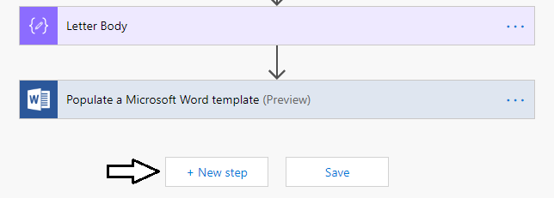

* 1. Type in **SharePoint Create File** into the action search box.
  2. Locate and select the SharePoint **Create File** action.

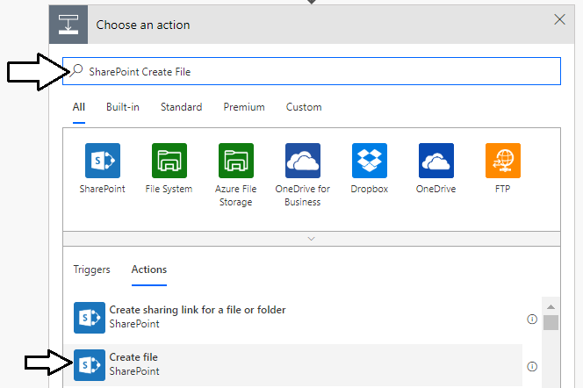

* 1. Configure the **Site Address** parameter with the URL to your SharePoint site.
  2. Configure the **Folder Path** to reference the **/Letters** document library.

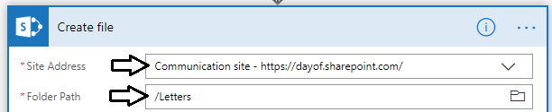

* 1. Place your cursor into the textbox for the **File Name** parameter.
  2. Type in an initial text value of **"Letter"** followed by a hyphen (**-**).
  3. Next click on the **FirstName** output parameter of the **For a selected item** trigger.

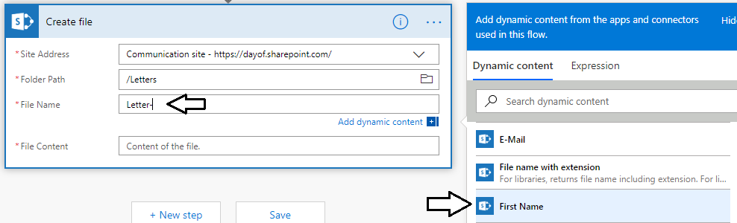

* 1. After adding the **First Name** parameter, add another hyphen followed by the **Last Name** parameter and then **".docx"**.



* 1. Place your cursor inside the textbox for the **File Contents** parameter and then add the **Microsoft Word document** parameter of the **Populate a Microsoft Word template** action as shown in the following screenshot.

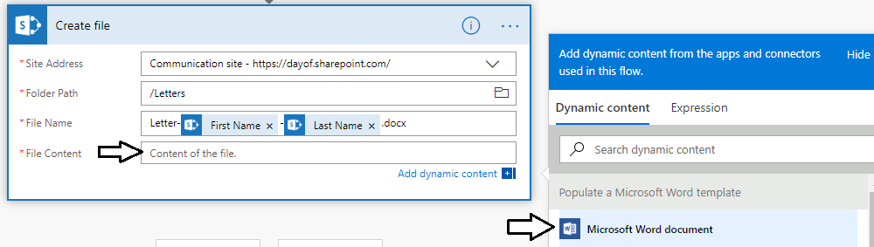

* 1. The **File Contents** parameter should now be configured with the **Microsoft Word document** output parameter.

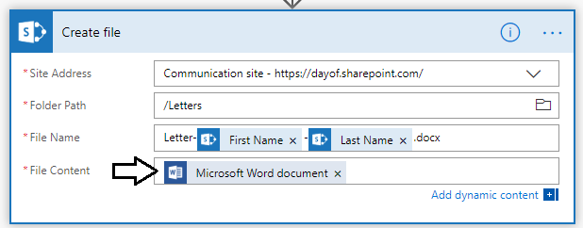

* 1. Click the **Save** button at the bottom of the flow designer to save your work.

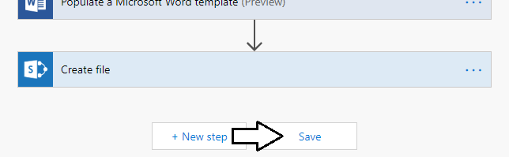

1. Test your work by select an item in the SharePoint **Customers** list and running the **Generate Customer Letter** flow.
   1. Navigate back to the **Customers** list in your SharePoint site.
   2. Select one of the custom items is in the **Customers** list.
   3. Drop down the **Flow** menu in the ribbon.

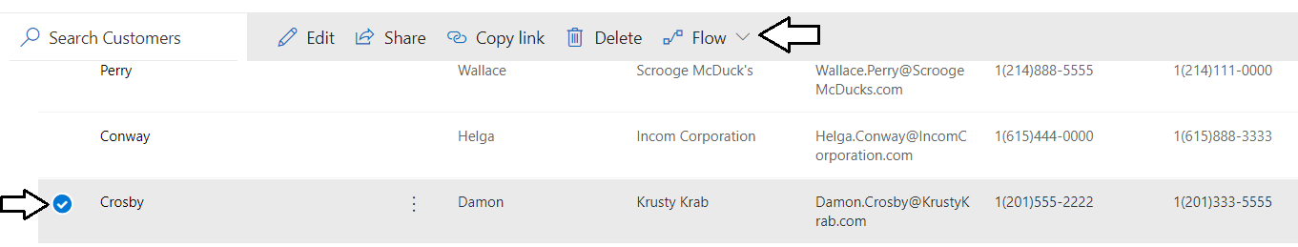

* 1. From the **Flow** menu, select the flow named **Generate Customer Letter**.

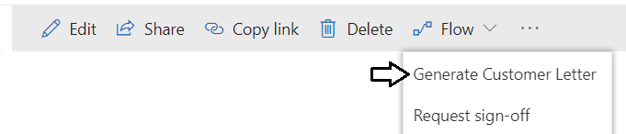

* 1. When the **Run Flow** pane appears, click **Continue**.

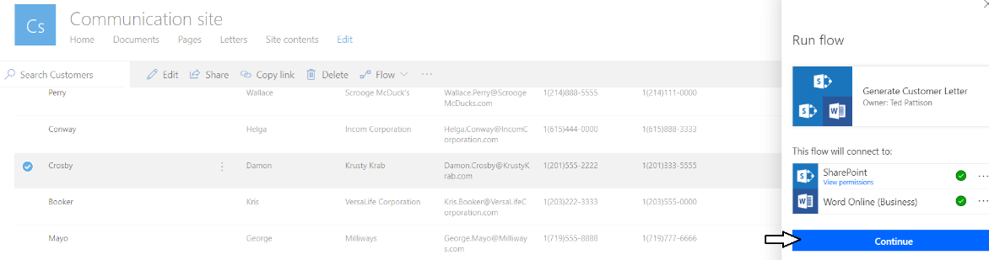

* 1. Next, click **Run flow** to run the flow on the currently selected customer item.

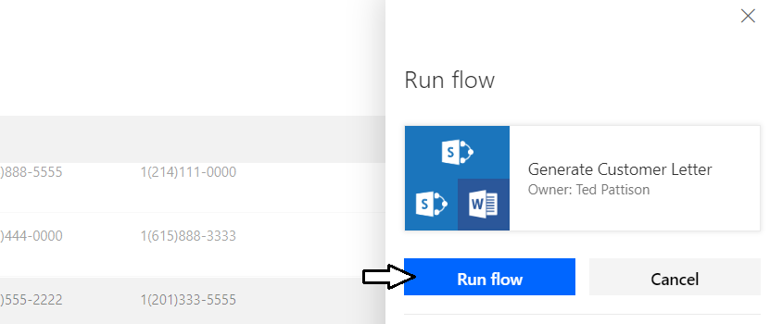

* 1. You should see a notification telling you that the flow has started.

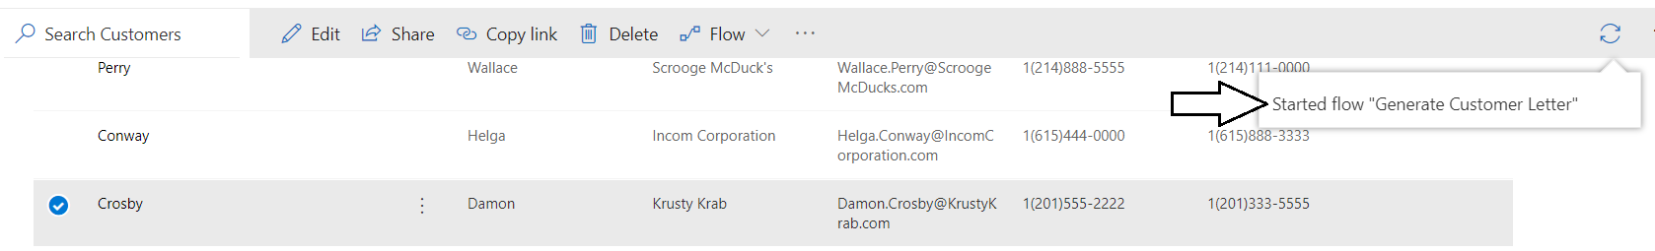

* 1. After a few seconds, navigate to the **Letters** document library.
  2. Your should see that a new Word document has been created as a result of the flow running.
  3. Click on the link to the new Word document to open it on Word Online.

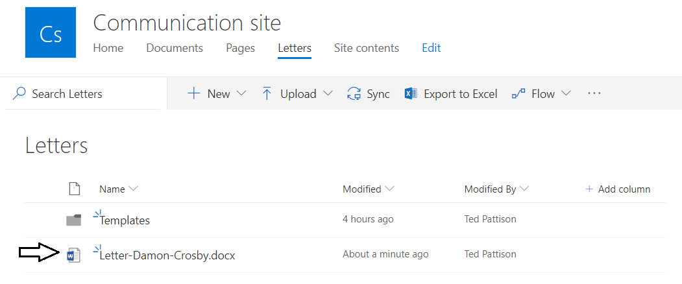

* 1. You should see that the new Word document has been generated with data from the selected customer item.

